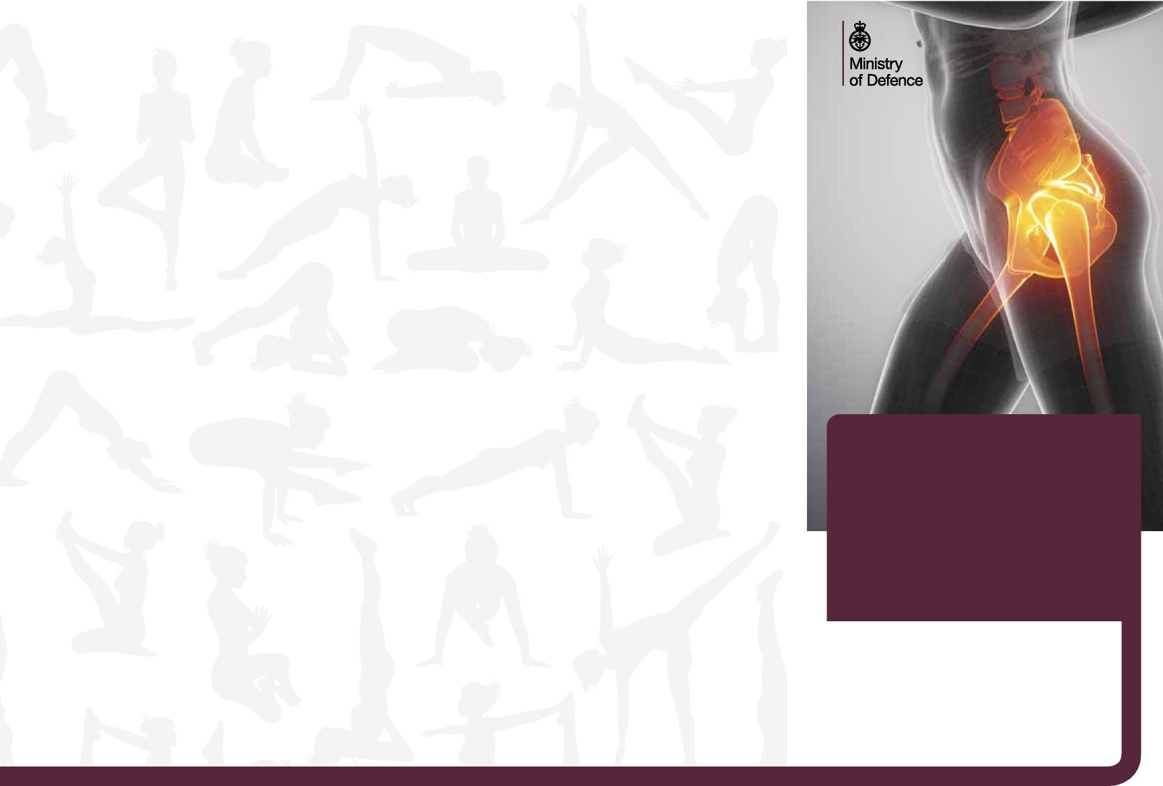
Further help
- Ensure that you drink adequately and avoid too many caffeinated drinks.
Remembering to exercise
Initially you may find it difficult to feel your pelvic floor muscles working. It takes some weeks to build their strength back up. Do persevere because you will soon regain awareness of the pelvic floor muscles contracting and relaxing. Like any exercise programme, don’t expect instant results. It will take weeks of regular exercise to improve your pelvic floor muscles. If you do your exercises three times a day, then you should notice a difference after about six weeks. And then you can drop to doing the exercises once a day.
- Avoid going to the toilet just in case
– you should only go when you feel your
bladder is full.
- Avoid putting on extra weight as this puts a strain on the pelvic floor muscles.
- Once you have strengthened up your pelvic floor, maintain this strength by continuing your exercises once a day.
Remembering to make time for your exercises can be a challenge but they need to become part of your daily routine and you should prioritise time for them in the same way you do for brushing your teeth.
Finally if you find the exercises prescribed here don’t help please see your GP, particularly if you have other troubling symptoms.
Download the NHS squeezy app – this helps women to remember to do their pelvic floor exercises and to do them in the right way.
They may refer you into the women’s health service for extra help.
https://www.nhs.uk/apps-library/squeezy/
This information has been modified from the CSP (Chartered Society of Physiotherapy), Bladder and bowel foundation and Royal College of Midwives information leaflet entitled ‘Personal Training for your Pelvic Floor’.
Pelvic
Floor
Advice and Exercise
Creative Media Design ADR008593
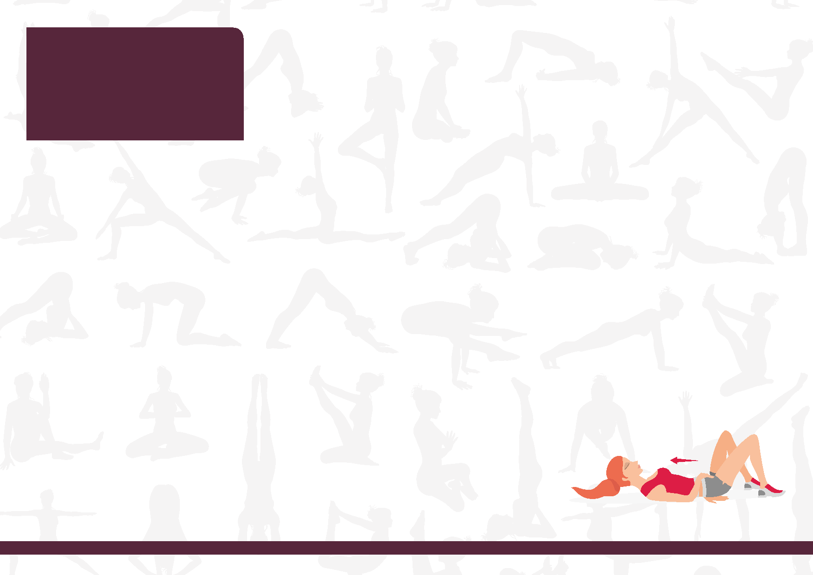
Where are the pelvic floor muscles?
Practising your exercises.
Now that you can activate the correct muscles you can following regime to improve both their stamina and responsiveness.
The pelvic floor is made up of muscles and ligaments that span the bottom of your pelvis, from the pubic bone to the coccyx.
How to activate the pelvic floor
The good news is that pelvic floor muscle exercises are easy to perform and can be done anywhere. Just a little time spent exercising them every day will help to either maintain or restore their strength.
What do the
pelvic floor muscles do?
These muscles act as a sling, supporting the uterus, bladder and bowel. They stay slightly tense to prevent leakage of urine from the bladder and wind or faeces from the bowel. They also increase sexual awareness for both you and your partner during intercourse.
- Squeeze and lift your pelvic floor muscles as hard as you can whilst still being able to breathe. Remember not to use your buttocks or legs. Hold for a count of 10 seconds. If your muscles feel too weak for 10 seconds, aim to build up slowly. Repeat this exercise up to 10 times.
Problems with the pelvic floor can present as loss of bladder and/or bowel control, pelvic organ prolapse (dropping) and reduced sensation or satisfaction with sex. Exercising the pelvic floor muscles can help protect you from these problems.
- Tighten and lift your pelvic floor muscles as quickly and as strongly as you can, without holding, then relax. Do this up to 10 times.
Aim to perform these 2 exercises three times over the course of a day, every day. Each set of exercises take about 2 ¹/₂ minutes.
Initial start exercising your pelvic floor in sitting. As you become stronger you should try changing to standing positions.
1 Sit comfortably and then tighten the muscles around your back passage as if preventing wind from passing. You should feel a squeezing and lifting sensation. You should not feel your buttocks or legs moving. You may feel your lower tummy tightening.
2 Next imagine stopping the stream of urine. You will be using the same group of muscles as before, but you may find this a little harder. (Do not try this when you are passing urine as repeated attempts may cause issues with bladder emptying)
3 Finally imagine trying to tighten and lift through the vaginal, as if you are trying to squeeze onto a tampon. Again, you will be using the same muscles.
4 Now try combining all these elements – squeezing and lifting from back to front.
Also, try to squeeze and lift your pelvic floor muscles each time you pick up anything heavy or before you cough and sneeze.
If you are not sure you are performing the exercises correctly then put your thumb into the vagina and perform the exercise.
You should feel a tightening around your thumb

